A Simple Login System can be designed using Labels, Textboxes, and Buttons where the user can enter a username and password, and the program checks whether they are correct and below are the clear codes for it.
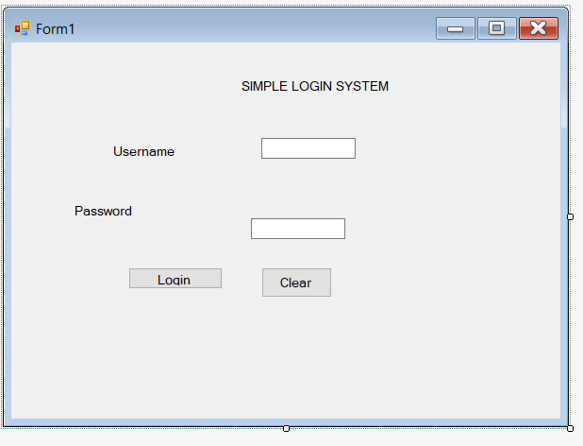
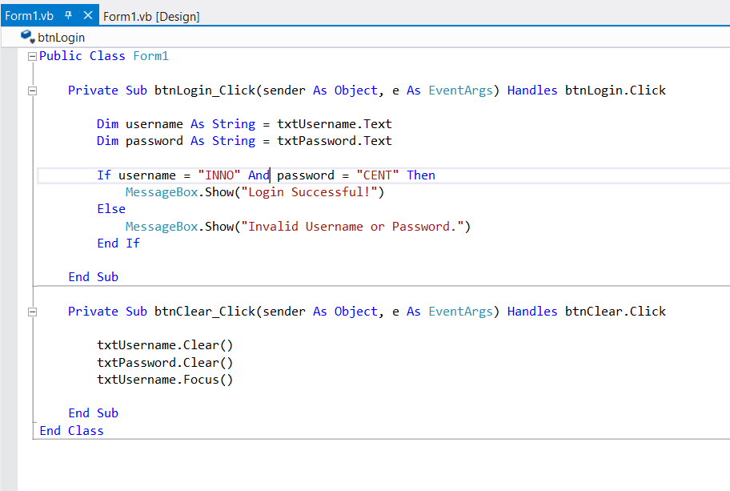
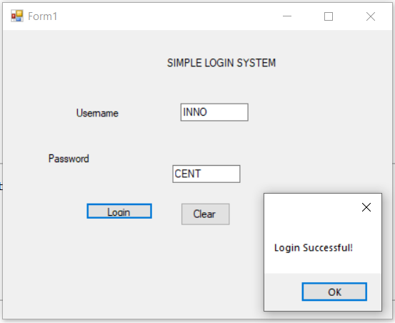
Explanation
- Labels identify the fields, such as Username and Password.
- Textboxes allow the user to enter their login details.
- Login Button checks whether the entered username and password are correct.
- Clear Button removes the entered information.

